SECTION 2
WASTE GENERATION AND MANAGEMENT

  - Introduction

This section of the 2018 Plan Update provides updated information on demographics, and waste generation and management within Sangamon County. Sangamon County has not revisited its original waste generation estimates since the 1990-1991 planning process. At that time the State provided planning grants to counties to do more detailed studies of waste generation, and typically counties hired consultants to conduct such studies (as Sangamon County did). To update the information on the County’s waste generation and management, the County conducted surveys of the municipalities, haulers and waste management facilities that manage the County’s municipal waste. That data is presented in this section.

It should be noted the data on the County’s recycling rate is limited to what was collected from the haulers. It does not include data from individual retailers (many recycle cardboard and plastic film internally) and local scrap yards, which it is recommended the County to attempt to quantify in subsequent years. However, the more important metric to monitor is the amount of waste disposed per person per day, because tracking waste disposed provides credit for source reduction and reuse efforts, which are otherwise nearly impossible to track, and ultimately the goal of a solid waste plan is to divert as much material from final disposal as possible and into the economic mainstream, creating a more circular economy. In addition, tracking the amount of waste disposed countywide, using the hauler and landfill surveys, is easier, more accurate and less time consuming than tracking down all the recycling and composting activity in the county.

2.2 Planning Area

Sangamon County is comprised of 26 municipalities and 24 townships (refer to Figure 2.1). Historically, the "planning area" has consisted of all of Sangamon County, both incorporated and unincorporated areas.

2.3 Demographics

Projections of population, households and employment (refer to Table 2.1) for Sangamon County and the planning area were developed using Census data and SangStat.

TABLE 2.1 SANGAMON COUNTY DEMOGRAPHICS

 | 1990 | 2000 | 2010 | Increase (%) from 1990 | 2015 Estimate
Population
Sangamon County | 178,749 | 188,951 | 197,465 | 10.5% | 198,496
Households
Sangamon County |  | 78,722 | 82,986 |  | 82,959
Employment
Sangamon County |  |  | 126,750 |  | 129,544
Notes:
1. Source for population and household data was the U.S. Census Bureau.
2. Source for the employment data was the June 2017 SangStat report prepared by the Springfield-Sangamon County Regional Planning Commission.

According to SangStat’s June 2017 report Sangamon County’s rate of population growth has declined from a growth rate of 10.5% between 1990-2010 to a growth rate of 4.4% from 2000-2010. With population growth slowing the County is also experiencing a decline in the growth of households. Finally, the employment estimates show a slow increase in employment in the County since 2010, but on overall decrease from 2005 to 2015 of 1.1% according to the SangStat report. This data on demographics is useful when evaluating waste generation rates in Sangamon County as waste generation is closely linked to population and employment trends. For the next five-year planning period it was assumed that Sangamon County’s population and employment will increase very gradually, but not enough to warrant any significant planning concerns.

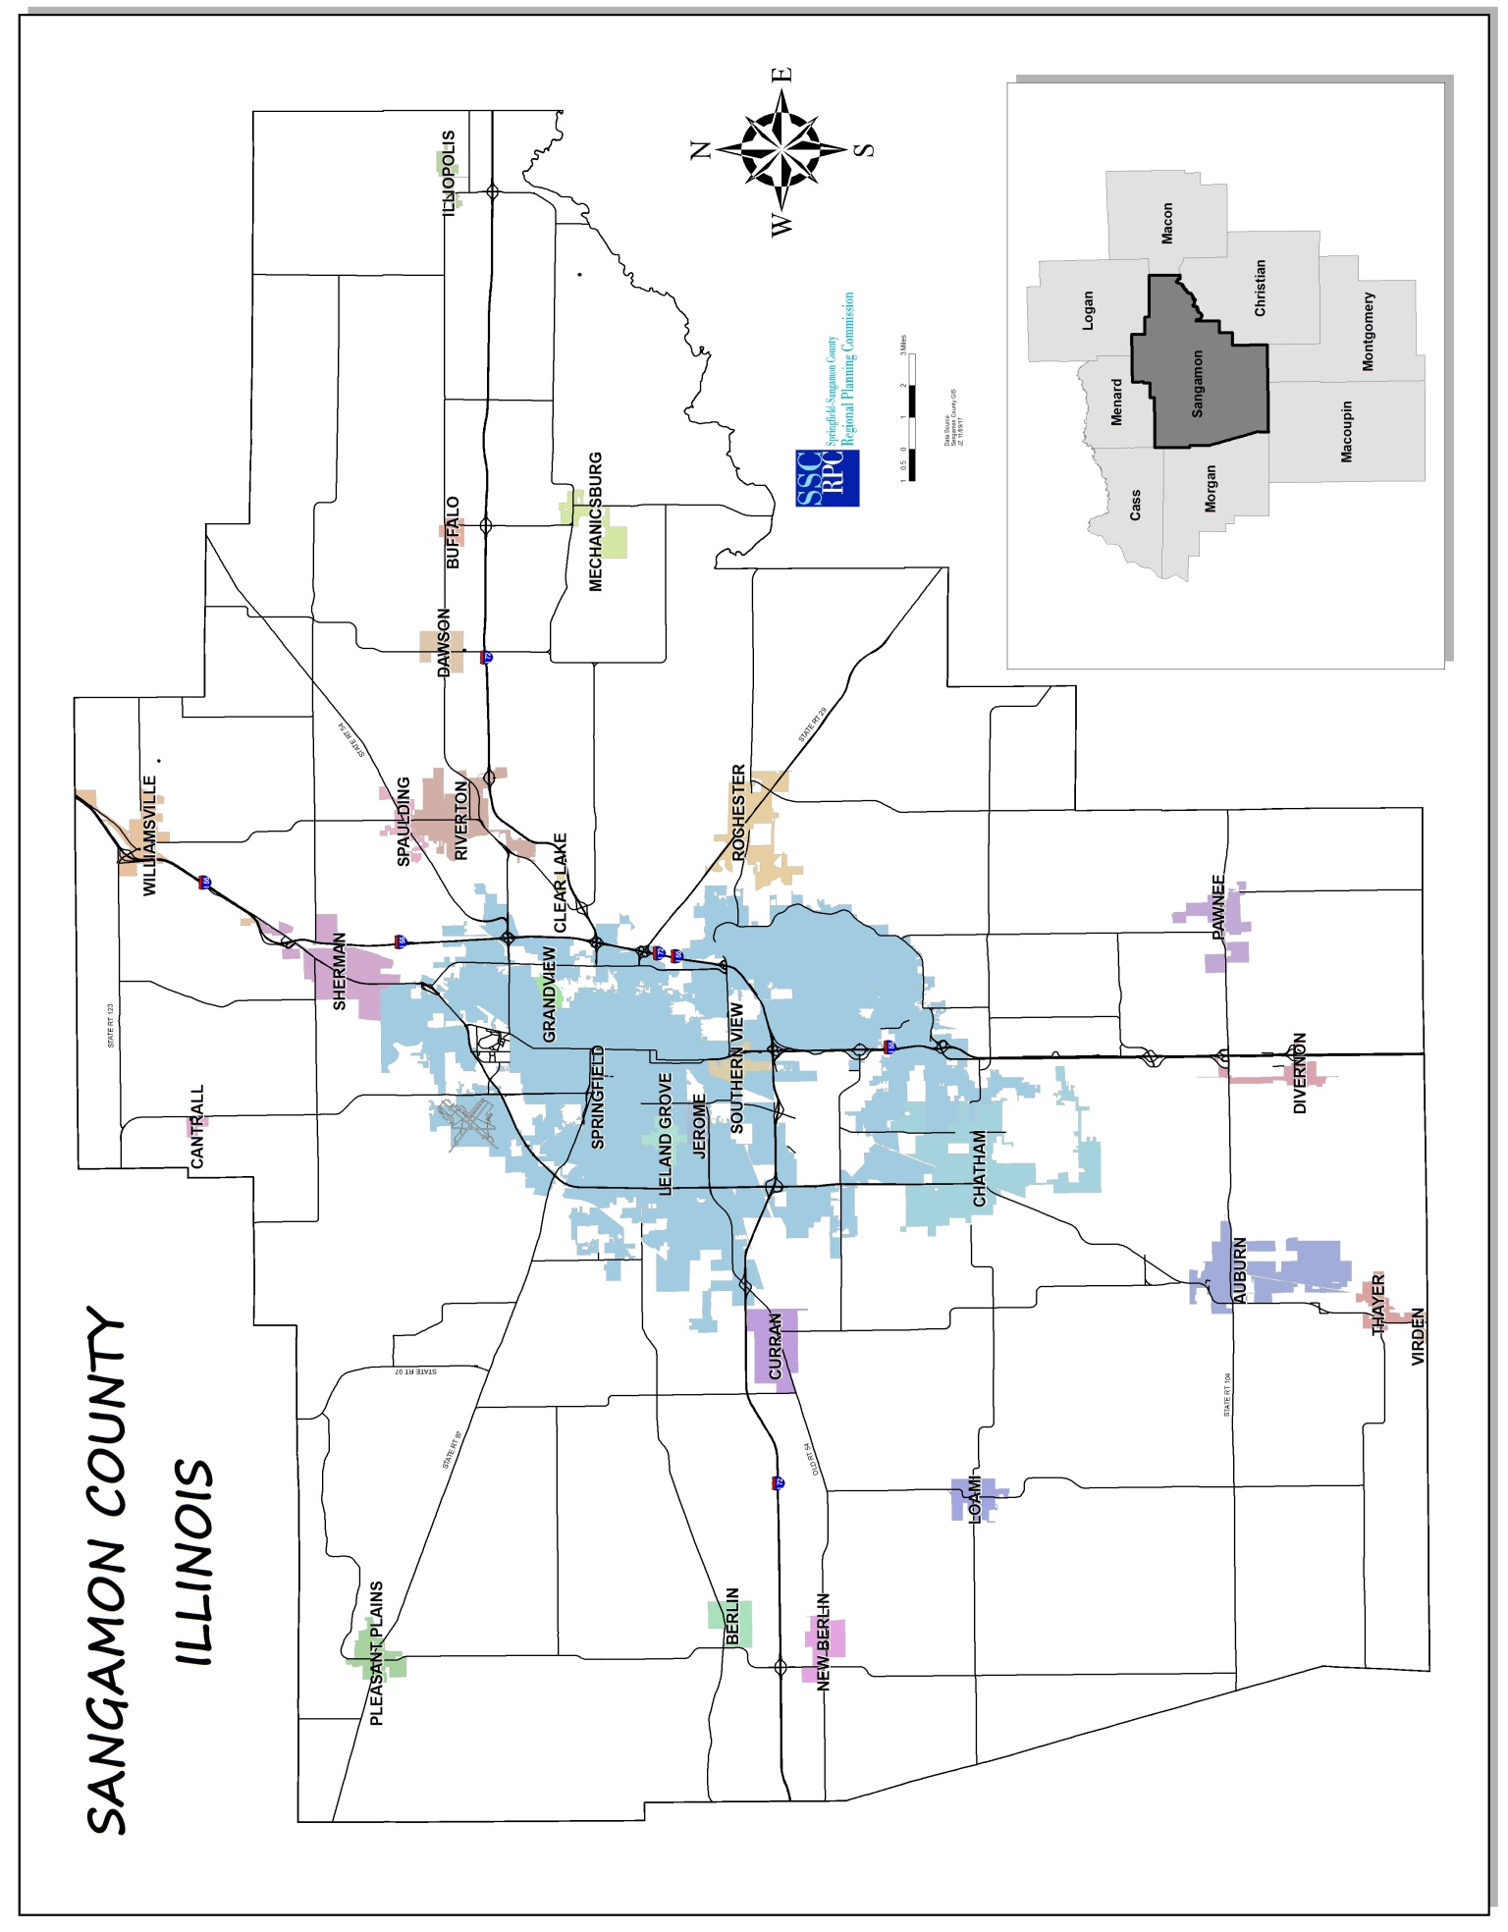
FIGURE 2.1 SANGAMON COUNTY PLANNING AREA
2.4 Waste Generation

This section presents updated waste generation information for the Sangamon County. The 1991 Solid Waste Management Plan estimated that County residents generated an average of 6.96 pounds per person per day (including residential, commercial and industrial waste, but no special or hazardous waste), approximately 636 tons per day county-wide or 232,102 tons per year in 1990. Of the total amount generated in 1990, 11,427 tons was recycled for a recycling rate of 5 percent (11,427/232,102).

As stated in Section 1, the County has not attempted to quantify waste generation data since the first Plan; the remainder of this subsection will present data collected from the haulers and landfills servicing Sangamon County for calendar year 2016. To protect the confidentiality of the haulers’ data on the amount of waste, recyclables and landscape waste they collected from Sangamon County sources in 2016, the data was aggregated.

The remaining subsections provide data on the amount of waste, recyclables and landscape waste generated in Sangamon County, based on locally collected data.

2.4.1 Disposal Rate Calculation

Municipal waste (MW) disposal rates (amount of waste taken to landfill) for 2016 are presented in Table 2.2. The following data sources were used to develop annual waste disposal rates:

- Hauler data reported by the haulers in response to a survey administered by Sangamon County in 2017. Surveys were sent to 14 haulers (WMI recently acquired Illini Disposal) and responses were obtained from 12, with the two non-responders being relatively small haulers.

- Landfill data reported by the landfill operators in central Illinois that receive waste from Sangamon County, these landfills included: 1) Sangamon Valley LF, Sangamon County, 2) Christian County LF, Christian County, 3) ADS Valley View LF, Macon County, and 4) Hickory Ridge LF, Pike County.

The hauler data and the landfill data as reported to the County for 2016 are shown in Table 2.2. Table 2.2 also shows the tonnage data as estimated in the 1991 Plan for comparison purposes. As the data show, the per capita disposal rates as estimated from the three different sources (1991 Plan, 2016 hauler survey data, and 2016 landfill survey data) are very close. The County has chosen to utilize the hauler reported data for its final estimates in this Plan Update. This will allow the county to continue to use this database for future plan updates, and provide for a consistent data base for planning purposes.

As shown in Table 2.2, disposal rates have decreased about 8 percent from 6.62 pounds per person per day (the 1991 Plan estimate) to 6.07 pounds per person per day according to the 2016 hauler reported data.

TABLE 2.2 SANGAMON COUNTY DISPOSAL DATA, 2016
Data Source | 1990-1991 Planning Data | 2016 Survey Data
Tonnage Data
Hauler Reported per 2017 Survey | NA | 219,905
Landfill Reported per 2017 Survey | NA | 170,443
Total Municipal Waste (MW) to Landfill | 220,675 | NA
Disposal Rate Calculations
Sangamon County Population | 182,729 | 198,496
Municipal Waste Disposal Rate, 1990 | 6.62 | NA
Municipal Waste Disposal Rate, Hauler Data, 2016 | NA | 6.07
Municipal Waste Disposal Rate, Landfill Data, 2016 | NA | 4.71
Notes:
- The 1990 MW to landfill was calculated by multiplying the 1990 population times 6.96 pounds per person per day, minus the amount reported recycled in 1990 (11,427 tons).
- Disposal rates are reported in pounds per person per day.
- NA means Not Applicable.

2.4.2 Recycling and Landscape Waste Quantities

The hauler survey conducted by the County included questions about the quantity of recyclables and landscape waste collected from the residential sector and the combined commercial/industrial sector in 2016. Overall, the County diverted 18,708 tons of recyclables and landscape waste for a recycling rate of approximately 8 percent (18,708/238,613). Since 1990 the County has increased its tons recycled/composted annually from 11,427 tons to 18,708 tons, an increase of 63 percent. The residential sector accounted for 11,808 tons recycled/composted and the commercial/industrial recycled/composted 6,900 tons. Table 2.3 summarizes the final waste generation rates, along with the recycling and composting data.

2.4.3 Summary Waste Generation

Municipal waste generation tonnages and per capita rates for 2016 are summarized in Table 2.3, based on the disposal and recycling/composting data reported in the hauler surveys and using the 2015 Census population estimate of 198,496 residents to calculate the per person per day generation rates. For 2016 it is estimated the County generated 238,613 tons or 6.59 pounds per person per day as compared to 6.96 pounds per person in 1990. This downward trend may be partially explained by the light weighting of packaging and consumer goods, so while the County’s residents may be generating the same or more individual items of waste, the weight of each of those items is generally less than they were in 1990.

TABLE 2.3 SANGAMON COUNTY WASTE GENERATION (2016)

 | 2016
Waste Generation, Annual Tonnage
Residential Landfilled | 134,967
Residential Recycled | 7,795
Residential Composted | 3,807
Commercial/Industrial Landfilled | 35,382
Commercial/Industrial Recycled | 3,977
Commercial/Industrial Composted | 40
Construction & Demolition Debris/Roll-off/Compactor Landfilled | 49,556
Construction & Demolition Debris/Roll-off/Compactor Recycled | 3,089
Total MSW Generation (tons per year) | 238,613
Waste Generation, Pounds Per Person Day
Residential | 4.05
Commercial/Industrial | 1.09
Construction & Demolition/Roll-off/Compactor | 1.45
Total MSW Generation Rate (pounds per person per day) | 6.59

Based on the preceding information, Sangamon County is estimated to have diverted 7.8% of the waste generated in the County from disposal in 2016. The remaining 92.2% of waste was landfilled (see Figure 2.2). More information on waste management methods and the facilities utilized is provided in Section 2.5 of this Plan Update.

FIGURE 2.2 WASTE MANAGEMENT METHODS (2016)

2.5 Waste Management Methods

2.5.1 Current Waste System

Sangamon County relies on a regional network of landfills, transfer stations, material recovery facilities (MRFs), compost sites, recycling drop-offs and metal scrap recyclers to manage the approximately 238,613 tons generated annually. These facilities located in Sangamon County are shown on Figure 2.3. Facilities not shown on the map, located in other counties, include:

- Advanced Disposal Services’ Valley View Landfill in Macon County
- Waste Management, Inc.’s Five Oaks Recycling and Disposal Facility in Christian County
- Peoria Disposal Company’s Hickory Ridge Landfill in Pike County
- Peoria Disposal Company’s Morgan County Transfer Station
- Midwest Fibers’ MRFs located in Decatur (Macon County), and Bloomington/Normal (McLean County)
- Decatur Composting Inc.’s compost site in Decatur (Macon County)
- Macon County Composting’s compost site in Decatur (Macon County)

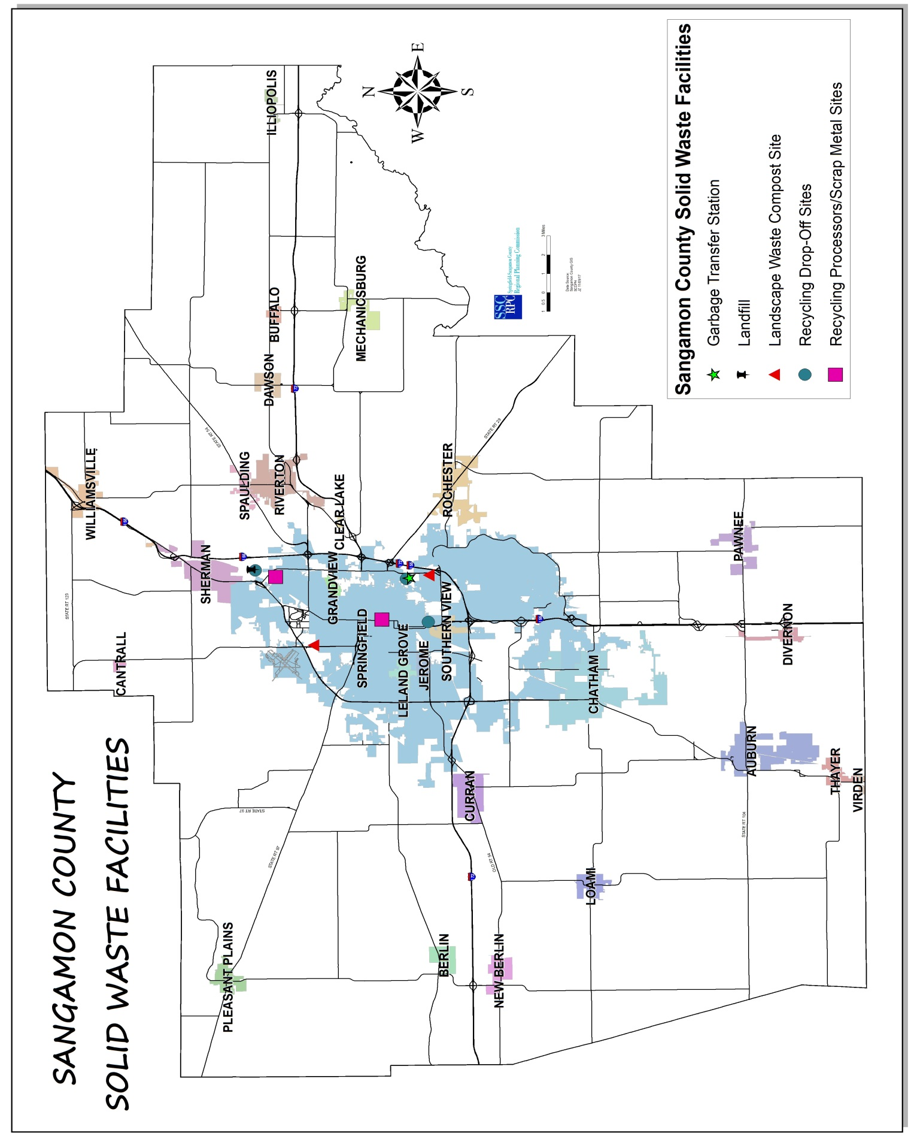
FIGURE 2.3 SANGAMON COUNTY
SOLID WASTE FACILITIES (2016)
According to discussions with the haulers, the County’s waste is disposed of in four different landfills, with the majority taken to either the Sangamon Valley Landfill or Five Oaks Landfill. According to data received from the landfills, in 2016 Sangamon County exported 92,873 tons outside of the county or 54% of the total amount landfilled. Table 2.4 shows the capacity, as of January 1, 2017, as reported by the landfills to the IEPA. As Table 2.4 indicates, the landfills utilized by Sangamon County have significant remaining capacity.

TABLE 2.4 LANDFILL CAPACITY INFORMATION

Facility | Capacity (01/01/17) |  | Throughput (2016) |  | Remaining Life (Years)
 | Gate Cu. Yds. | Tons | Gate Cu. Yds. | Tons
Sangamon Valley LF | 5,745,767 | 1,741,142 | 301,153 | 91,258 | 19.1
Five Oaks LF | 24,033,049 | 7,282,742 | 712,774 | 215,992 | 33.7
Valley View LF | 19,376,987 | 5,871,814 | 531,700 | 161,121 | 36.4
Hickory Ridge LF | 3,010,756 | 912,350 | 456,977 | 138,478 | 6.6
Notes:
1. Source: IEPA, Illinois Landfill Disposal Capacity Report, July 2017. Capacities reported to IEPA in gate cubic yards converted to tons using IEPA conversion factor of 3.3 gate cubic yards per ton.
2. Capacity information is for permitted capacity and does not include any capacity that may have local siting approval but is not yet permitted.

2.5.2 Municipal Waste Management Information

The County issued a survey to the 26 municipalities in the county and received responses from all 26. The survey asked questions regarding the role of the municipality in providing for or regulating in any way the residential waste hauling and recycling services, which haulers operated in the municipality, if curbside or drop off recycling was provided and other general information as presented in Table 2.5. Findings from the municipal survey include:
- Five municipalities have an exclusive franchise contract with one hauler, six regulate haulers via licensing, one utilizes a local ordinance and the remaining 11 who answered the question have an open, subscription system. Overall, except for the five municipalities with an exclusive franchise contract, the remaining towns allow the residents to choose among several haulers who operate within the corporate limits.
- Eighteen municipalities have a curbside recycling option for their residents, which range in participation. Only four towns that have curbside recycling have data on the programs.
- Thirteen towns offer some sort of drop-off site or special collection event. Three of the towns responding to this question had permanent drop-off, most responding indicated the events were mainly spring or fall clean-up events, or special collections for electronics.
- The majority of municipalities indicated a willingness to evaluate more recycling options, and to work with the County on the Plan Update. One municipality indicated it was contemplating a possible exclusive franchise to reduce road wear and tear, and to reduce rates.

TABLE 2.5 MUNICIPAL SURVEY RESULTS, SANGAMON COUNTY PLAN UPDATE

Sangamon County Municipality | ​Franchise Contract with Hauler | ​License Hauler | ​Regulate services through ordinance | ​Open Subscription | ​License or regulate commercial hauling | ​Curbside Recycling Offered to Residents | ​Drop-off or Special Event Recycling for Residents | ​Does Municipality Have Recycling and Disposal Data | ​Interested in Evaluating Options to Increase Recycling | ​Hauler(s) Operating in Municipality
City of Auburn |  |  |  | x | ​ | ​ | ​ | x | ​x | FLW, WM
Village of Berlin |  |  |  | x | ​ |  | ​x | ​ | ​ | ​FLW, RS
Village of Buffalo | x |  |  |  | ​ | ​x | ​ |  | ​x | ​WM
Village of Cantrall |  |  |  | ​ | ​ | ​ | ​ |  | ​ | ​ LA, RS, WM
Village of Chatham |  | x |  | ​ | x | x | x |  | ​x | ​ LA, RS, WM
Village of Clearlake |  |  | ​ | ​x |  | ​ | ​ |  |  | LA, RS, WM
Village of Curran |  |  |  | x |  |  | x |  | x | ​FLW, LA, WM
Village of Dawson | x |  | ​ |  | ​ | ​ | ​ | ​ | ​x | ​WM
Village of Divernon | x |  |  |  | ​x | ​x | ​ | x |  | ​FLW
Village of Grandview |  | x |  |  | ​x | ​x | ​x |  | x | ​LA, RS, WM
Village of Illiopolis | x |  |  |  | ​x | ​x | ​x | ​ | ​x | ADS
Village of Jerome |  |  | ​ |  | x |  |  |  | x
City of Leland Grove |  |  |  | x |  | x | ​ | ​ | x | ​LA, RS, WM
Village of Loami |  |  | ​ | ​x | ​ | ​x | ​x | ​ | ​ | ​CW,FLW, LA
Village of Mechanicsburg | x |  |  |  | ​ | ​x | ​ | ​x | ​ | ​ADS
Village of New Berlin |  |  |  | ​x | ​ | ​x | ​x | ​ | x | ​FLW, RS
Village of Pawnee |  |  | ​ | ​x | ​ | ​x | x |  | ​ | FLW, LA, WM, RS
Village of Pleasant Plains |  | x | ​ | ​ | ​ | ​x | ​ |  | ​x | LA, PDC, RS
Village of Riverton |  | x |  |  | ​ | ​x | ​ | ​ | ​x | ​LA, RS, WM
Village of Rochester |  | x | ​ | ​ | ​ | ​ | ​ | ​ | ​ | CLE, LA, RS, WM
Village of Sherman |  |  | ​ | x | ​ | x | ​x |  | ​x | LA, RS, WM
Village of Southern View |  | x |  |  | ​x | ​x | ​x |  | ​ | ​LA, RS, WM
Village of Spaulding |  |  | ​ | x | ​ | ​x | ​x |  | ​x | ​ LA, RS, WM
City of Springfield |  |  | x |  | ​ | ​x | ​x | x | ​x | ​ LA, RS, WM
Village of Thayer |  |  |  |  |  | ​x | ​ |  | x | FLW
​Village of Williamsville |  |  | ​ | ​ | x | ​x | ​x | ​ | ​x | ​​ LA, RS, WM
Notes:
- “X” denotes that the municipality does provide the service or program.
- “DO” denotes drop-off, and “SE” denotes special event.
- Hauler abbreviations: ADS-Advanced Disposal System, CW-Capitol Waste, CLE-Cleeton Sanitation Service, FLW-Flowers Sanitation, LA-Lake Area Disposal, RS-Republic Services, WM-Waste Management, Inc, PDC – Peoria Disposal Company

A summary of waste disposal, recycling and landscape waste data and rate information is provided in Table 2.6 for several municipalities in the County that provided the data in their responses to the municipal survey.

TABLE 2.6 2016 RESIDENTIAL WASTE, RECYCLING AND RATE DATA

Municipality | Recycling (tons) | Yard Waste (tons) | Disposed (tons) | Generated (tons) | Diversion (%) | Rate Information
City of Auburn | 0 | 0 | 1,872 | 1,872 | 0% | $20 per month for refuse
Village of Berlin |  |  |  |  |  | $20 per month for refuse
Village of Buffalo |  |  |  |  |  | $18.95 per month for refuse
Village of Cantrall |  |  |  |  |  | $18 to $21.67 per month for refuse
Village of Curran |  |  |  |  |  | $19 per month for refuse
Village of Divernon |  |  |  |  |  | $15 per month for 95 gallon refuse; $10 per month for biweekly recycling in 95 gallon
Village of Illiopolis |  |  |  |  |  | $14.60 per month for refuse
City of Springfield | 4,423.6 | 1,119.5 | 31,410.7 | 36,953.7 | 15% | Ordinance caps rates at $15 per month (1 can), $18 per month (2 can), both options include curbside recycling.
Village of Thayer |  |  |  |  |  | $19 per month for refuse; $20 per month for recycling
Village of Williamsville |  |  |  |  |  | $15 (1 can) or $18 (2 can) with weeklly recycling; $18 per month with biweekly recycling

The hauler survey also provided information on the estimated recycling participation rate for the haulers’ residential and commercial customers. Without naming the haulers the estimated rates by hauler were:

- Hauler A: 51% residential, 12% commercial
- Hauler B: 65% residential, 45% commercial
- Hauler C: 0% residential, 0% commercial
- Hauler D: 0% residential, 0% commercial
- Hauler E: 10% residential, 0 % commercial
- Hauler F: 50% residential, 1% commercial
- Hauler G: 85% residential, 15% commercial
- Hauler H: 0% residential, 0% commercial
- Hauler I: 17% residential, 0% commercial
- Hauler J: 50% residential, 15% commercial

The hauler and municipal surveys show a wide variance in recycling participation rates and the types of recycling programs offered to residents. This along with a lack of data on the tonnages associated with recycling programs on a municipal level indicate the need to further evaluate what changes, if any, should be pursued at the municipal level to ensure more comprehensive recycling programs and data gathering.

2.6 Waste Composition

The Illinois Recycling Association (IRA) and Illinois Department of Commerce and Economic Opportunity (DCEO) commissioned a study, the Illinois Commodity/Waste Generation and Characterization Study, of waste generation and composition in Illinois dated March 30, 2015. As part of the IRA/DCEO study, nine samples of waste were taken from the Sangamon Valley Landfill in 2014 and sorted into approximately 80 constituent components. Five of the samples were taken from loads of primarily residential waste, and four were taken from loads of primarily institutional/commercial/industrial (ICI) waste.

The results of the composition study are summarized in Table 2.7, and show the general constituent breakdown for the Sangamon Valley Landfill sorts, and the comprehensive data on statewide averages for a more detailed constituent list. Sangamon County was fortunate to have access to data that reflects the waste landfilled by its residents and businesses, though the number of samples was somewhat limited they did point to some trends we are seeing statewide as well: 1) organics represent the largest major category of landfilled wastes and is a target of more advanced diversion programs throughout North America (now over 400 curbside organics collection programs), 2) significant quantities of valuable materials are still landfilled and not recycled, Sangamon County residents are throwing away nearly 1,100 tons of aluminum per year worth $1.4 million (assuming $1,300 per ton), and 3) construction and demolition (C&D) debris is prevalent in the Sangamon County samples (as well as statewide) and represents a waste stream the County may want to focus on for future diversion programs.

TABLE 2.7 COMPOSITION OF LANDFILLED WASTE (BY WEIGHT)

Material | Sangamon Valley LF-Residential Waste | Sangamon Valley LF- ICI Waste | Illinois  Average
Paper | 22.1 % | 20.4% | 23.0%
Newspaper |  |  | 1.9%
Corrugated |  |  | 9.1%
Other Paper |  |  | 12.0%
Plastic | 14.7% | 12.2% | 16.2%
#1 - #7 Containers |  |  | 4.0%
Plastic Film |  |  | 7.7%
Other Plastic |  |  | 4.5%
Glass | 3.8% | 3.1% | 3.2%
Metal | 3.5% | 1.7% | 4.2%
Aluminum Cans |  |  | 0.5%
Tin Cans |  |  | 0.9%
Other Metal |  |  | 2.8%
Organics | 33.2% | 16.5% | 27.9%
Yard Waste |  |  | 3.1%
Food Scraps |  |  | 18.0%
Other Organic |  |  | 6.8%
Inorganics | 1.2% | 15% | 4.1%
Computers/Electronics |  |  | 1.0%
Appliances |  |  | 0.4%
Tires |  |  | 0.2%
Other Inorganic |  |  | 2.5%
Textiles | 3.1% | 1.2% | 5.1%
HHW | 0.6% | 0.02% | 0.6%
Construction/Demolition | 17.7% | 29.4% | 15.2%
Wood |  |  | 8.0%
Other |  |  | 7.2%
Total | 99.9% | 100.0% | 100.0%
# Samples01 | 5 | 4 | 263
Source:
1. CDM, Illinois Commodity/Waste Generation and Characterization Study, March 30, 2015

